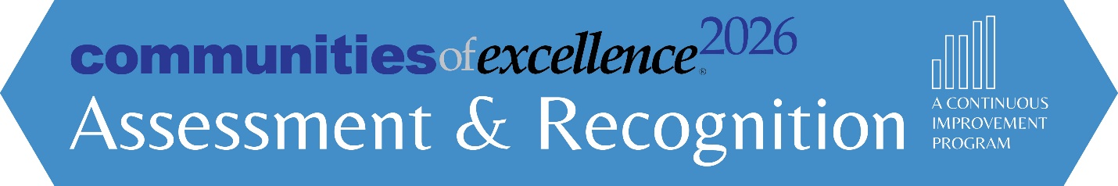Commitment to Community Excellence (Level 1)
Instructions for Assessment

Step 1
Download or email us at snorling@communitiesofexcellence2026.org to request the Communities of Excellence Framework, including the Community Profile questions. Make sure you are using the 2020-2021 version. The version date can be found on the top left of the cover page.

Step 2
Submit the Request for Assessment (page 2 of this document) by Monday May 15th, 2023. COE 2026 will respond within 3 days of receipt.

Note on Cost of the Assessment: IF your community is a member of the Communities of Excellence National Learning Collaborative, the cost for this assessment is included in your participation fee. If your community is NOT a member of the National Learning Collaborative there is a $1500 fee for this assessment. You will receive an invoice within 5 business days of submitting the Request for Assessment Form.

Step 3
Format your Profile for submission:
Page Limit – maximum of 10 pages | Clearly label all figures
Glossary of abbreviations required | Page numbering required
Columns are okay | Font-Minimum size 11-point
Tables & diagrams make efficient use of space.

Step 4
Respond to the Community Profile questions. Respond to each Section (P.1 and P.2) and all questions within, using their number labels and titles (e.g., P.1 Community Description), and label your answers to all questions (e.g., P.1a(1) Community Definition and Identity). You may use the Community Profile Worksheet.
Step 5
Email completed Application to snorling@communitiesofexcellence2026.org with the name of the community from your Request for Assessment and “Commitment to Community Excellence Assessment” in the subject line by Saturday, July 15th. COE 2026 will then assign a small group of volunteer reviewers to conduct an assessment.

Step 6
On Sunday, October 15th, you will receive a feedback report based on the reviewers’ assessment and an opportunity to schedule a one-hour briefing with a reviewer or staff member.
Request for Commitment to Community Excellence Assessment
- Commitment to Community Excellence is the 1st level of the Communities of Excellence Assessment and Recognition Program.
- This request form must be submitted by Monday, May 15th, 2023.
- The Commitment to Community Excellence Application must be submitted by Saturday July 15th, 2023.
- On Sunday, October 15th, your community will receive (1) a written feedback report that includes key highlights and considerations for the usefulness of your Community Profile in serving as a basis for community improvement; and (2) the option for a 1-hour briefing with Communities of Excellence 2026 (COE 2026) staff or reviewers assigned to your assessment.
Name of Community:
______________________________________________________________________________
Brief Description including Geographic Area (City, County, Region, etc.):
______________________________________________________________________________
Name of Backbone Organization:
______________________________________________________________________________
Official to Represent Community (typically from the Backbone Organization):
______________________________________________________________________________
Name Title Organization
______________________________________________________________________________
Phone Number Email Address
Terms and Conditions (please check all that apply):
☐ I understand that we are requesting a formal assessment be conducted on our community as described above, and that this assessment will be reviewed by COE 2026 staff and volunteers.
☐ My community is NOT a member of the National Learning Collaborative and therefore I understand that I am responsible for paying the $1500 assessment fee before I can receive my feedback report.
☐ I understand that the feedback report we receive will be shared by COE 2026 only if authorized by the person listed above.
☐ I give COE 2026 permission to publicize the name of our community if we receive the Commitment to Community Excellence Recognition.
☐ I give COE 2026 permission to share our Community Profile on the COE 2026 public website. (Visit this link for an example of how the information is displayed).

______________________________________________________________________________
Signature and Date (agreeing to the checked terms and conditions)
- Email completed form to: snorling@communitiesofexcellence2026.org

