**Instructions for Community of Excellence (Level 3) Assessment**

**Step 1**

Review the [qualification criteria](http://communitiesofexcellence2026.org/what-we-do/recognition-program/recognition-levels.html) for the Community of Excellence Assessment. Then

[download](https://communitiesofexcellence2026.org/what-we-do/framework-agreement-page.html) or email Communities of Excellence 2026 ([snorling@communitiesofexcellence2026.org](mailto:snorling@communitiesofexcellence2026.org)) to request a pdf of the Communities of Excellence Framework. If using your own version, make sure you have the August 2019 revision. The revision date can be found on the bottom of the last page of the COE Framework.

**Step 2**

Submit Request for Assessment (see the next page) by Monday June 15th, 2020. COE 2026 will respond with an approval of the request within 3 days of receipt.

**Step 3**

Format your application for submission:

|  |  |
| --- | --- |
| Basics:   * Left margin: minimum ¾ inch * Right margin: minimum ½ inch * Font: minimum size 11 points * Columns are okay, but not required * Number the pages. * Clearly label all figures. | Page Limits:   * Community Profile: 5- 7 pages * Responses to Categories 1-7: 28-30 pages * *Total of 35 pages for Community Profile and Categories 1-7* |

**Step 4**

**Content.** Respond to the questions in the Community Profile and Categories 1-7.

For Categories 1 -6, focus your responses on describing systematic, effective approaches and appropriate deployment as well as evidence of learning and integration among processes.

For Category 7, include text, graphs, and/or tables that document performance levels, trends, comparisons and integration for all key results. At least three data points are necessary for a trend.

Also include a glossary of abbreviations used in your application.

**Format.** For the Profile and Categories 1-6, label each section with its number and title. When possible, use tables and diagrams to make efficient use of space.

***Example:***

1.1 Community Leadership

1.1(1) How do your community leaders set your community’s shared vision and values?

*Your response would go here.*

For Category 7, Results, label your response as follows. Results may be presented as charts, graphs or text.

***Example:***

7.1 Community and Process Results

7.1(1) What are your community’s results for its offerings in the areas of health, education, the economy and quality of life?

*Your response would go here.*

*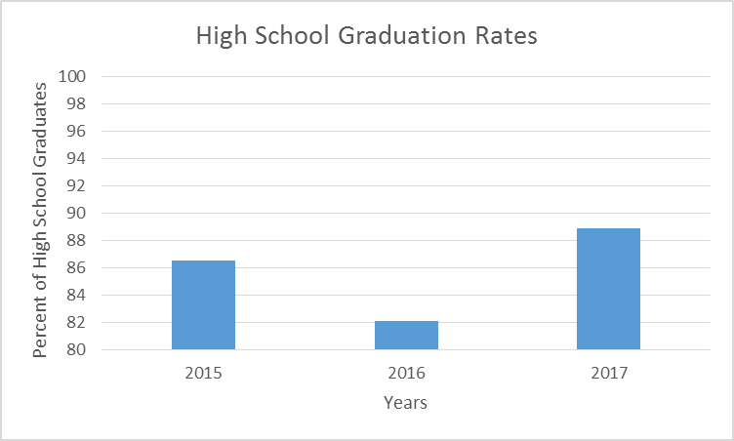***[Example of Chart] [Example of Graph]** 

*Note that chart and graph include data performance levels (i.e. 86.5%) and trend (at least three data points). Arrow on right indicates desired direction of trend.*

**Step 5**

Email your completed application to [snorling@communitiesofexcellence.org](mailto:snorling@communitiesofexcellence.org) in Microsoft Word (.doc, docx) format. In the subject line, include the name of the community as written in your Request for Community of Excellence Assessment, plus “Community of Excellence Application.” COE 2026 will then assign examiners to conduct an assessment.

***Sample Subject Line:*** Hershey, Pennsylvania Community of Excellence Application

**Step 6**

You will receive a written feedback report and an opportunity to schedule a one-hour briefing with an examiner or staff member on Thursday, October 15th.

**Request for Community of Excellence Assessment**

* Community of Excellence is the 3rd level of the Communities of Excellence 2026 Assessment and Recognition Program.
* This request form must be submitted by Monday June 15th, 2020.
* The Community of Excellence Application must be submitted by Wednesday July 15th, 2020.
* On Thursday October 15th, your community will receive (1) a written feedback report; (2) the option for a 1-hour briefing with Communities of Excellence 2026 staff or examiners assigned to your assessment; and (3) if selected, the Community of Excellence public recognition.

1. **Name of Community:**

______________________________________________________________________________

1. **Brief Description, including Geographic Area (50 words):**

______________________________________________________________________________

______________________________________________________________________________

______________________________________________________________________________

1. **Name of Backbone Organization(s):**

______________________________________________________________________________

1. **Official to Represent Community (typically, but not always, from the Backbone Organization(s)):**

______________________________________________________________________________

Name Title Organization

______________________________________________________________________________

Phone Number Email Address

**Terms and Conditions:** I understand that we are requesting that a formal assessment be conducted on our community as described above, and that this assessment will be reviewed by Communities of Excellence 2026 staff and volunteers. The formal feedback report is proprietary to our community and will be shared by COE 2026 only if authorized in writing by the person listed in question 4 above. Communities of Excellence 2026 may publicize the name of our community if we successfully complete the Community of Excellence Assessment process.

______________________________________________________________________________

Signature and Date (agreeing to the terms and conditions)

1. **Email completed form to:** [**snorling@communitiesofexcellence2026.org**](mailto:snorling@communitiesofexcellence2026.org)