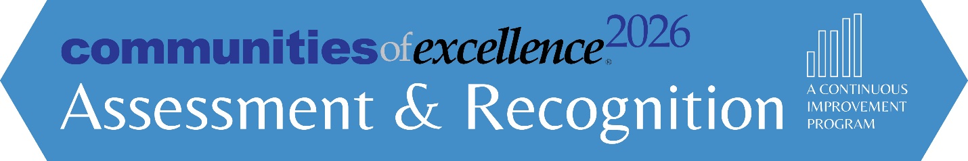

**Community of Excellence (Level 3) Instructions for Assessment**

**Step 1**

[Download](http://communitiesofexcellence2026.org/what-we-do/framework/community-profile.html) or email us ([snorling@communitiesofexcellence2026.org](mailto:snorling@communitiesofexcellence2026.org)) to request the Communities of Excellence Framework. **Make sure you are using the 2020-2021 version**. The version date can be found on the top left of the cover page.

**Step 2**

**Submit Request for Assessment** (see page 3 of this document) by **Monday May 15th, 2023**. COE 2026 will respond within 3 days of receipt.

***Note:*** *The cost for this assessment is included with your participation IF your community is part of Phase 1, 2, or 3 of the Communities of Excellence National Learning Collaborative. If your community is NOT participating, or is part of the Alumni Program, there is a $5000 assessment fee. You will receive an invoice within 5 business days of submitting the Request for Assessment Form.*

**Step 3**

Format your document for submission:

|  |  |
| --- | --- |
| Page Limit – maximum of 35 pages (maximum of 5-7 pages for the Community Profile) | Clearly label all figures |
| Left Margin minimum ¾ inch | Right Margin minimum ½ inch |
| Columns are okay | Font-Minimum size 11-point |
| Tables & diagrams make efficient use of space | Page numbering required |
| Glossary of abbreviations required |  |

**Step 4**

**Content.** Respond to the questions in the Community Profile, and Categories 1-7 of the Communities of Excellence Framework.

For Categories 1-6, focus your responses on describing systematic, effective approaches, appropriate deployment as well as evidence of learning and integration among processes.

For Category 7, include text, graphs, and/or tables that document performance levels, trends, comparisons, and integration for the key results requested. At least three data points are needed for a trend.

Label your answers to all questions. You may use the Community Profile and Category Worksheets, which are pre-labeled.

**Format.**

For the Profile and Categories 1-6, label each section with its number and title. When possible, use tables and diagrams to make efficient use of space.

***Example:***

1.1 Community Leadership

1.1(1) How do your community leaders set your community’s shared vision and values?

*Your response would go here.*

For Category 7, Results, label your response as follows. Results may be presented as charts, graphs or text.

***Example:***

7.1 Community and Process Results

7.1(1) What are your community’s results for its offerings in the areas of health, education, the economy and quality of life?

**[Example of Graph]**

*Your response would go here.*

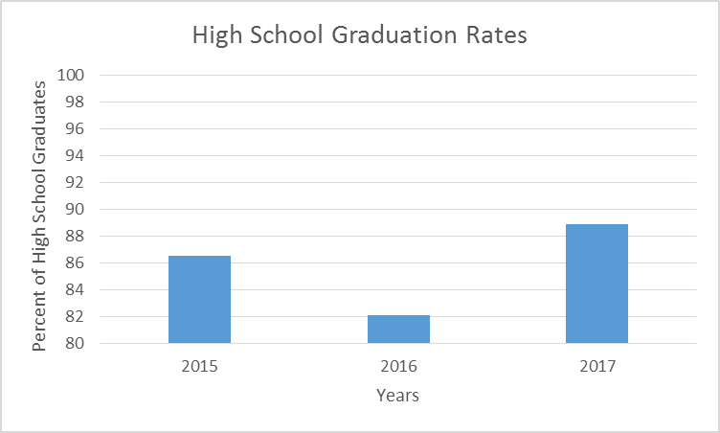

**[Example of Chart]**

*Note that chart and graph include data performance levels (i.e. 86.5%) and trend (at least three data points). Arrow on right indicates desired direction of trend.*

**Step 5**

**Email completed Application** to [snorling@communitiesofexcellence2026.org](mailto:snorling@communitiesofexcellence2026.org) with the name of the community from your Request for Assessment and “Community of Excellence Assessment” in the subject line by **Saturday, July 1st**. COE 2026 will then assign a small group of volunteer reviewers to conduct an assessment.

**Step 6**

On **Sunday, October 15th**, you will receive a written feedback report based on the reviewers’ assessment and an opportunity to schedule a one-hour briefing with a reviewer or staff member.

**Request for Community of Excellence Assessment**

* Community of Excellence is the 3rd level of the Communities of Excellence Assessment and Recognition Program.
* This request form must be submitted by Monday, May 15th, 2023.
* The Community of Excellence Application must be submitted by Saturday July 1st, 2023.
* On Sunday, October 15th, your community will receive (1) a written report highlighting key strengths and opportunities for improvement to serve as a basis for community improvement and prioritization; and (2) the option for a 1-hour briefing with Communities of Excellence 2026 staff or reviewers assigned to your assessment.

**Name of Community:**

______________________________________________________________________________

**Brief Description including Geographic Area (City, County, Region, etc.):**

______________________________________________________________________________

**Name of Backbone Organization:**

______________________________________________________________________________

**Official to Represent Community (typically from the Backbone Organization):**

______________________________________________________________________________

Name Title Organization

______________________________________________________________________________

Phone Number Email Address

**Terms and Conditions (please check all that apply):**

I understand that we are requesting a formal assessment be conducted on our community as described above, and that this assessment will be reviewed by COE 2026 staff and volunteers.

My community is NOT a member of the National Learning Collaborative Phases 1, 2, or 3 and therefore I understand that I am responsible for paying the $5000 assessment fee before I can receive my feedback report.

I understand that the feedback report we receive will be shared by COE 2026 only if authorized by the person listed above.

I give COE 2026 permission to publicize the name of our community if we receive the Community of Excellence Recognition.

I give COE 2026 permission to share our Community Profile on the COE 2026 public website. (Visit this [link](https://communitiesofexcellence2026.org/what-we-do/learning-collaborative/communities/excelsior-springs-missouri-2022.html) for an example of how the information is displayed).

______________________________________________________________________________

Signature and Date (agreeing to the checked terms and conditions)

**Email completed form to:** [**snorling@communitiesofexcellence2026.org**](mailto:snorling@communitiesofexcellence2026.org)